1. 
2. Let’s say we want to download a file in parts where each part is handled by a different thread, we want to show the total number of bytes downloaded so far. So we need to store total bytes somewhere and have multiple threads incremented as they are downloading file.   
   This is called **Race Condition** which means multiple threads racing/competing to update/modify a shared resource.  
   Let me show you.
3. 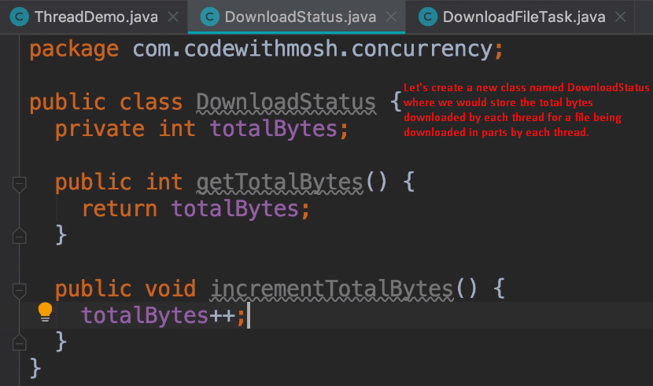
4. 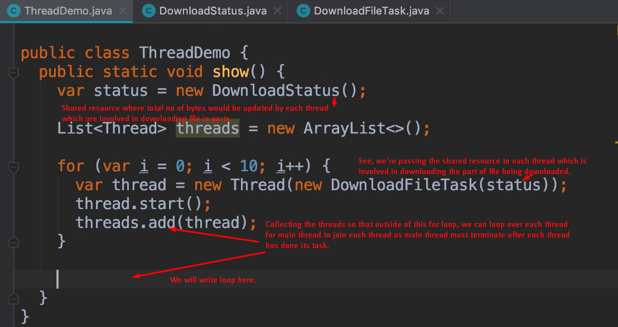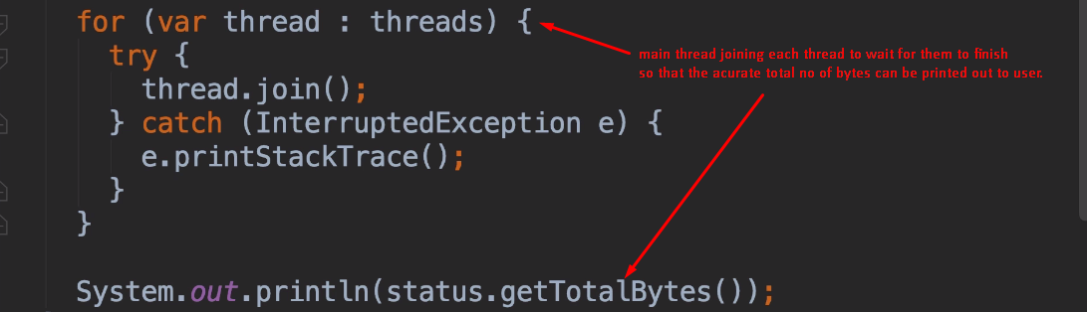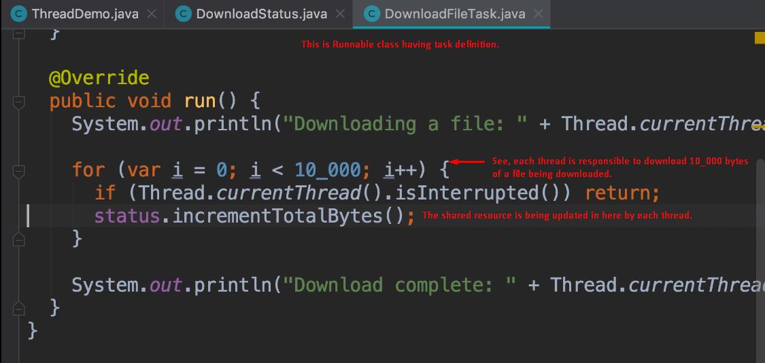
5. 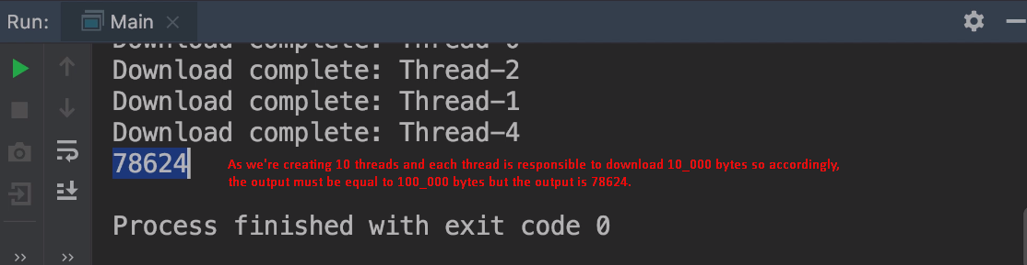
6. What happened under the hood?
   1. 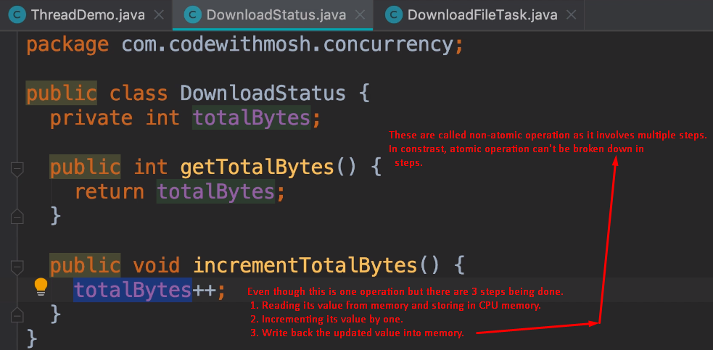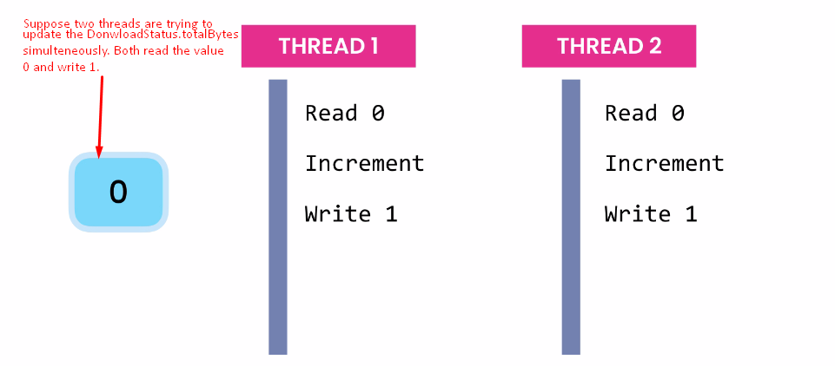
   2. This is how we lose update.